**Agribusiness Connections Program**

Wednesday, January 10th 2018

2:00 pm – 5:00 pm

2018 Wisconsin Agribusiness Classic

Alliant Energy Center Exhibition Hall

**Attending Companies**

**Page Information** **Page #**

Company Contact Listing . . . . . . . . . . . . . . . . . . . . . . . . . . . . . . . . . . . . . . . . . . . . . . . . . . 2

Ag Source Laboratories . . . . . . . . . . . . . . . . . . . . . . . . . . . . . . . . . . . . . . . . . . . . . . . . . . . 3 - 4

Allied Cooperative . . . . . . . . . . . . . . . . . . . . . . . . . . . . . . . . . . . . . . . . . . . . . . . . . . . . . . . 5

Country Visions Cooperative . . . . . . . . . . . . . . . . . . . . . . . . . . . . . . . . . . . . . . . . . . . . . . 6

The DeLong Company . . . . . . . . . . . . . . . . . . . . . . . . . . . . . . . . . . . . . . . . . . . . . . . . . . . . 7

Helena Chemical Company. . . . . . . . . . . . . . . . . . . . . . . . . . . . . . . . . . . . . . . . . . . . . . . . 8

Insight FS . . . . . . . . . . . . . . . . . . . . . . . . . . . . . . . . . . . . . . . . . . . . . . . . . . . . . . . . . . . . . . 9 - 10

INTL FCStone . . . . . . . . . . . . . . . . . . . . . . . . . . . . . . . . . . . . . . . . . . . . . . . . . . . . . . . . . . . 11 - 12

Landmark Services Cooperative . . . . . . . . . . . . . . . . . . . . . . . . . . . . . . . . . . . . . . . . . . . . 13

Pearl City Elevator . . . . . . . . . . . . . . . . . . . . . . . . . . . . . . . . . . . . . . . . . . . . . . . . . . . . . . . 14 - 15

Premier Cooperative . . . . . . . . . . . . . . . . . . . . . . . . . . . . . . . . . . . . . . . . . . . . . . . . . . . . . 16

United Cooperative . . . . . . . . . . . . . . . . . . . . . . . . . . . . . . . . . . . . . . . . . . . . . . . . . . . . . . 17 - 18

**

|  |  |  |
| --- | --- | --- |
| **Ag Source Laboratories** | **Helena Chemical Company** | **Pearl City Elevator, Inc.** |
| Steve Peterson | Terry Walsh | Pennie Groezinger |
| VP Laboratory Services | West Bend Branch Manager | HR & Credit Manager |
| 106 N. Cecil Street | 2525 Townline Road | 119 S. Main Street |
| PO Box 7 | West Bend, WI 53090 | Pearl City, IL 61062 |
| Bonduel, WI 54107 | 262-689-0906 | 800-851-8584 |
| 715-758-2178 | [Walsht@helenachemical.com](mailto:Walsht@helenachemical.com) | [pgroezinger@pce-coops.com](mailto:pgroezinger@pce-coops.com) |
| [speterson@agsource.com](mailto:speterson@agsource.com) | [www.helenaconnect.com](http://www.helenaconnect.com/) | [www.pce-coops.com](http://www.pce-coops.com/) |
| [www.agsource.com](http://www.agsource.com/) |  |  |
|  | | |
| **Allied Cooperative** | **Insight FS** | **Premier Cooperative** |
| Dakotah Smiley | Tom Trevorrow | Shayla Danz |
| Recruiter and HR Generalist | Human Resources Manager | Human Resources |
| 540 S. Main Street | PO Box 359 | PO Box 230 |
| Adams, WI 53910 | Jefferson, WI 53549 | Mount Horeb, WI 53572 |
| 608-339-3394, ext. 237 | 920-674-1010 | 608-308-4922 |
| [dsmiley@allied.coop](mailto:dsmiley@allied.coop) | [TTrevorrow@growmark.com](mailto:TTrevorrow@growmark.com) | [Shayla.danz@premiercooperative.com](mailto:Shayla.danz@premiercooperative.com) |
| [www.allied.coop](http://www.allied.coop/) | [www.insightfs.com](http://www.insightfs.com/) | [www.premiercoooperative.com](http://www.premiercoooperative.com/) |
|  | | |
| **Country Visions Cooperative** | **INTL FCStone** | **United Cooperative** |
| Jennifer Kuffel | Ryan J. Moe | Dan Harmsen |
| Agronomy Marketing Specialist | Regional Director | HR Director |
| 709 Mill Street | 605 Hwy 169 N Suite 1025 | N7160 Raceway Road |
| PO Box 460 | Plymouth, MN 55441 | Beaver Dam, WI 53916 |
| Reedsville, WI 54230 | 952-852-2911 | 920-887-1756 |
| 920-901-4341 | [ryan.moe@intlfcstone.com](mailto:ryan.moe@intlfcstone.com) | [danh@unitedcooperative.com](mailto:danh@unitedcooperative.com) |
| [jkuffel@cvcoop.com](mailto:jkuffel@cvcoop.com) | [www.intlfcstone.com](http://www.intlfcstone.com/) | [www.unitedcooperative.com](http://www.unitedcooperative.com/) |
| [www.countryvisionscoop.com](http://www.countryvisionscoop.com/) |  |  |
|  | | |
| **The DeLong Company** | **Landmark Services Cooperative** |  |
| Aaron Cole | Ashley Wilcox |  |
| Product, Sales and Service Manager | HR Generalist |  |
| 501 Front Street | 1401 Landmark Drive |  |
| PO Box 552 | Cottage Grove, WI 53527 |  |
| Clinton, WI 53525 | 608-819-3163 |  |
| 608-676-2255 ext. 1170 | [ashley.wilcox@landmark.coop](mailto:ashley.wilcox@landmark.coop) |  |
| [Acole@delongcompany.com](mailto:Acole@delongcompany.com) | [www.landmark.coop](http://www.landmark.coop/) |  |
| [www.delongcompany.com](http://www.delongcompany.com/) |  |  |



AgSource Laboratories

AgSource Laboratories is a leader in environmental, food and agricultural laboratory analysis and information management services. Our dedicated crop consultants and agronomy specialists in Bonduel deliver over 100 years of combined experience. Services include analyses of soil, plant tissue, manure, fertilizer and water, as well as nutrient management planning (NMP) services, GPS soil sampling, GPS mapping, aerial imagery and crop scouting.

We use state-of-the-art resources and reliable expertise to consistently produce results our clients trust. We take pride in putting our years of experience to work in helping feed a growing world and safeguard a healthy environment for future generations.

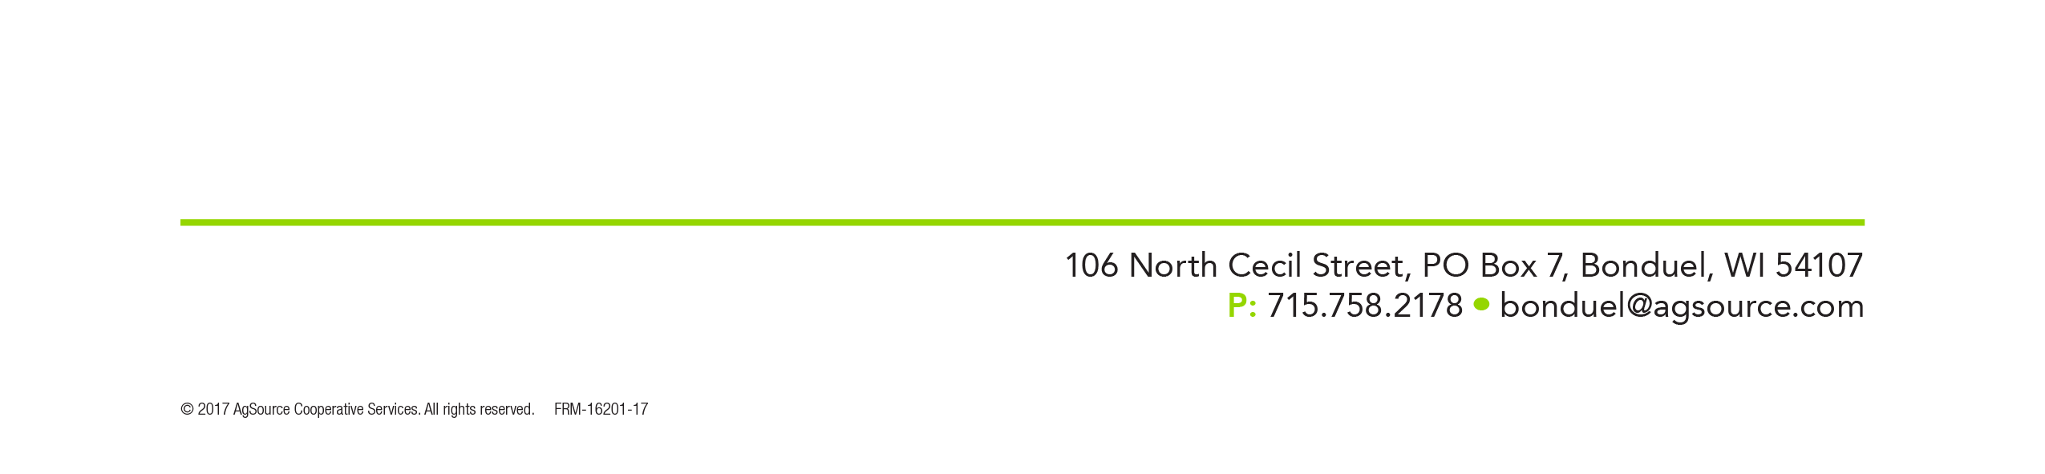

**AgSource Laboratories**

POSITION OPENINGS

**Title:** Field Service Technician-Internship

**Accountable to:** GPS-NMP Manager

**Location:** Wisconsin

**Position Objective**

AgSource Laboratories is seeking 2-3 Field Service Technician Interns to work with our field staff in providing scouting, GPS field sampling and NMP data collection for the 2018 growing season.

**Major Areas of Responsibility**

* Provide GPS sampling and NMP Data management collection.
* Maintain detailed records of field data and samples collected.
* Deliver and make arrangements for transfer of data and soil samples collected.
* Crop Scouting fields of assigned customers weekly over the course of the growing season
* Participate in training for weed and disease identification
* Communicate with growers on field observations
* Participate in end of day sessions to evaluate daily field observations
* Responsible for supplies and the maintenance and repairs of AgSource vehicle and field sampling equipment

**Qualifications**

* A general knowledge of production agriculture and working towards a Ag degree
* Good work ethic and communication skills
* Physically capable to walk fields and enjoys a outside work environment
* Holds a valid driver’s license
* Must exhibit initiative when working individually and must work well in a team environment

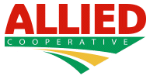

Allied Cooperative has a long and proud history serving mid-Wisconsin’s farmers. With roots that date back to 1917, our co-op was formed when a group of farmers joined together in order to gain greater purchasing power and maximize their potential for success in their farming operations. That legacy is one we take seriously. Though we have had mergers, acquisitions and many changes over the years, our shared commitment to our member-owners has never wavered. We exist for our members!

Today Allied Cooperative has operations in Adams, Arcadia, Blair, Galesville, Mauston, Mindoro, Plainfield, Plover, Tomah, West Salem, Wisconsin Dells and Wisconsin Rapids. We provide a wide variety of products and services including agronomy, feed, grain, LP and refined fuels, auto parts, hardware, tires and convenience stores.

Internship Opportunities: Agronomy Sales & Marketing Interns

Agronomy Operational Interns

Crop Scouting Interns

Career Full-Time Job Opportunities:

Liquid Applicators

Dry Applicators

Agronomy Operations

Dakotah Smiley

Recruiter & Human Resources Generalist

540 S. Main Street

Adams, WI 53910

[dsmailey@allied.coop](mailto:dsmailey@allied.coop)

608-339-3394 Etx. 237

[www.allied.coop](http://www.allied.coop)

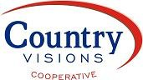

**2018 Summer Internship Opportunities Available**

Country Visions Cooperative is seeking summer 2018 agricultural Interns with a focus in Agronomy.

Country Visions Cooperative is based out of Eastern Wisconsin and can trace its roots back to 1918. Country Visions Cooperative has grown over the years because of their dedication to service and building long-term relationships from generation to generation.

Country Visions Cooperative is looking for interns who have a passion for agriculture, learning, working hard, and being around people. Through this internship we will try to give you the best developing experience for your future career.

Internship tasks would include: Crop Scouting, Research Projects, Sales Practice, further understanding of Agronomy, Grain, and Products. Country Visions Cooperative is willing to help customize the experience to make it what you would also like to learn.

The locations seeking interns include:

* Plymouth
* Ripon
* Reedsville
* Valders
* Chilton

[If interested, please send your resume and cover letter to jkuffel@cvcoop.com.](mailto:jkuffel@cvcoop.com)

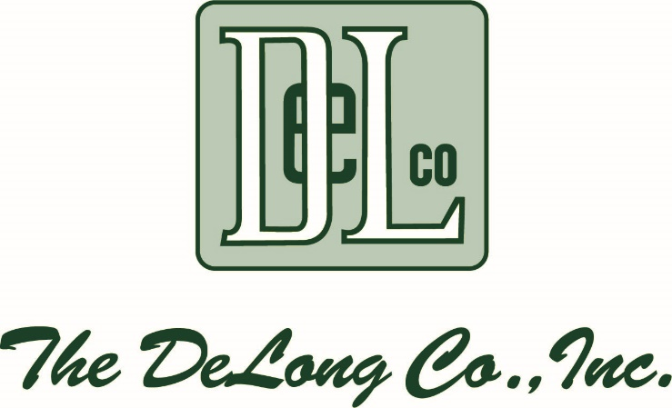

Let’s Talk!

For over 100 years, our goal at The DeLong Co., Inc. has been to provide information, products and services to the farming industry.

In addition to being a grain elevator and major supplier of food grains domestically and internationally, we also provide seed, fertilizer and chemical inputs and services for growers in Wisconsin and Illinois.

We offer:

• Delivery and storage of feed grains and seed products

• Sell feed and seed manufactured for use in livestock feeds

• Pet foods and

• Wild bird seeds

The DeLong Co. operates two warehouses that are used to wholesale and distribute various feed and pet products to dealers in Wisconsin, Illinois and Indiana.  
  
Headquartered in Clinton, Wisconsin, our business operates locations around the U.S. and comprises five divisions of agricultural sales and service:

• Agronomy

• Grain

• Seed

• Wholesale Distribution

• Transportation

The DeLong Co., Inc. remains a family owned and managed organization.

Seasonal Openings: Fulltime Openings for all DeLong Agronomy Locations: Summer Agronomy Internship Applicators

Summer Agronomy Internship Agronomy Sales

Summer Agronomy Internship Seed Sales

Seasonal Help at all Locations Local Truck Drivers

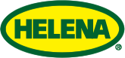

Helena Chemical Company is one of the country’s largest distributors of agriculture inputs. Based in Collierville, TN, Helena has over 450 locations across the United States. In addition to providing customers with crop protection inputs, seed, fertilizer and other agronomic services, Helena also has its own line of products and four manufacturing plants.

Because Helena Chemical is a rapidly growing organization; we are always searching for motivated agriculture candidates throughout the US, in the areas of: sales (wholesale and retail), operations (applicators, general labor, truck drivers, etc.) & management (product, category, branch, area, etc.)

Terry Walsh

West Bend Branch Manager262-689-0906

[Walsht@helenachemical.com](mailto:Walsht@helenachemical.com)

www.helenaconnect.com

2525 Townline Road

West Bend, WI 53090



**GROWMARK, Inc.**

*GROWMARK is an agricultural cooperative providing agronomy, energy, facility planning, and logistics products and services, as well as grain marketing and risk management services in more than 40 states and Ontario, Canada. GROWMARK owns the FS trademark, which is used by affiliated member cooperatives to serve more than 250,000 customers.*

*The GROWMARK System began in 1927 when Illinois Farm Bureau members organized local agricultural cooperatives in order to meet their growing demand for a reliable fuel supply. Soon, nine of those cooperatives combined to form Illinois Farm Supply Company, which merged with similar organizations in Iowa and Wisconsin to form FS Services, Inc. In 1980, GROWMARK, Inc. was established through the consolidation of FS Services, Inc. and Illinois Grain Corporation.*

*FS cooperatives in Illinois, Iowa, and Wisconsin still make up GROWMARK’s core membership. GROWMARK has now grown into an expansive system with $7 billion in annual sales (FY2016). With four wholly or partially-owned subsidiaries, nine retail subsidiary divisions, and controlling interests in several related endeavors, the GROWMARK System is flourishing.*

*At GROWMARK we are proud of our rich history. Our mission, to improve the long-term profitability of our member-owners, is reflected in all we do. We strive to be the best agricultural cooperative system in North America, which is made possible through the dedication of our skilled and respected employees.*

**Insight FS, div. of GROWMARK, Inc.**

*Insight FS is an agricultural cooperative serving patrons throughout Wisconsin and Michigan's Upper Peninsula.*

*We are a cooperative, owned and democratically controlled by our members, but our products and services are available to anyone.*

*We are proud to be a member of the FS System of cooperatives. FS is a legacy brand that has been a core part of Midwest agriculture since 1955. Today, FS companies are located in nine states and the province of Ontario and are known for delivering customers trusted advice that is professional, dependable and local.*

*At Insight FS, our products and services are backed by sound recommendations that will help your business thrive. We have a vested interest in your success, and our focus is clear - when you succeed, we succeed.*



**Insight FS** - 2018 Current Internship Offerings

Intern, Energy - Insight FS - Jefferson, WI

Intern, Exploring Ag - Insight FS - Brodhead, WI

Intern, Exploring Ag - Insight FS - Jefferson, WI (2 positions)

Intern, GMK Agronomy - Insight FS - Amherst Junction

Intern, GMK Agronomy - Insight FS - Cobb, WI

Intern, GMK Agronomy - Insight FS - Southwest Wisconsin

**Insight FS** - Current Job Openings, as of October 1, 2017

Applicator I - Insight FS - Amherst Junction, WI

Applicator I - Insight FS - Arlington, WI

Applicator I - Insight FS - Brodhead, WI

Applicator I - Insight FS - Jefferson, WI

Applicator I - INSIGHT FS - Mapleton (Oconomowoc), WI

Applicator I - Insight FS - Marshall, WI

Assistant Manager, Plant/Location - Insight FS - Jefferson, WI

Laborer, General - INSIGHT FS - Ishpeming, MI

Mechanic - Insight FS - Jefferson, WI

Manager, Plant/Location - Insight FS - Marshall, WI

Manager, Plant/Location - Insight FS - Marshfield, WI

Operator, Feed Mill/Delivery - INSIGHT FS - Waupun, WI

Operator, Feed Mill/Delivery - Insight FS - Waupun, WI

Seed Sales Specialist - Insight FS - Stevens Point Area

Spec, Sales & Delivery - Liquid Fuels - INSIGHT FS - Antigo, WI

Spec, Sales & Delivery - Propane - Insight FS - Jefferson, WI

Spec, Sales & Delivery - Propane - INSIGHT FS - Marxville, WI

Spec, Sales & Delivery - Propane - INSIGHT FS - Wautoma, WI

Tech, Service - Propane & Petroleum - INSIGHT FS - Antigo, WI

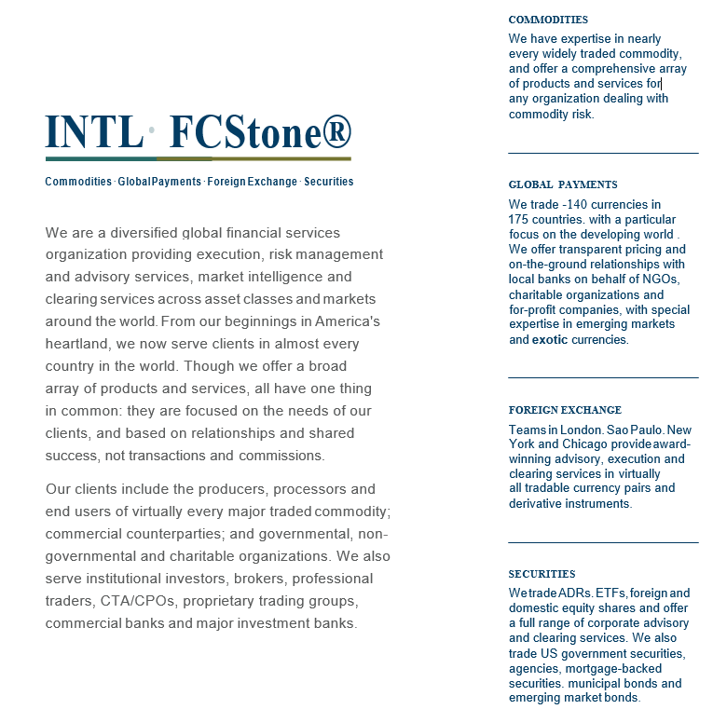

# About this Job:

**Position Purpose:** Interns are responsible for maintaining satisfied clients by delivering assistance and support to the staff of the department they are assigned to on various projects.

# Primary Accountabilities/Responsibilities:

* Maintains a satisfied level of customer service with clients both internal and external.
* Properly handles client requests through responsiveness, follow-up and escalation to a more senior team member if necessary.
* Begins to develop a current knowledge of the laws and regulations that pertain to the department they are assigned to.
* Keeps abreast of new developments in the field their internship is in.
* Works proactively with other team members.
* Maintains prompt and regular attendance.
* This list of responsibilities may not be all-inclusive and can be expanded to include other duties or responsibilities as needed.

# Job Requirements:

* Prefer candidates with a minimum of 2 years completion of college coursework
* Agribusiness & Economics majors preferred
* Strong interpersonal skills, able to comfortably and pleasantly deal with a variety of people
* Strong customer skills
* Ability to correctly make decisions involving client issues/problems including when to escalate the problem to a more senior consultant
* Exceptional written and oral communication skills
* Excellent organizational and planning skills
* Ability to effectively learn and acquire new knowledge and skills
* Ability to share knowledge and work in a strong team oriented environment
* Strong work ethic and emphasis on attention to details
* Proficient in Word, Excel, PowerPoint, and e-mail
* Must be authorized to work in the US for any employer

# Contact:

**Ryan J. Moe**

Regional Director

Toll Free: 800-854-6490

Direct: 952-852-2911

[ryan.moe@intlfcstone.com](mailto:ryan.moe@intlfcstone.com)

# INTL FCStone Financial Inc. – FCM Division

# 605 Hwy 169 N

**Suite 1025**

**Plymouth, MN 55441**



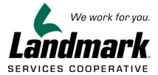

Landmark Services Cooperative is a member-owned cooperative business providing [agronomy](https://www.landmark.coop/landmark-agronomy/), [animal nutrition](https://www.landmark.coop/animal-nutrition/), [grain](https://www.landmark.coop/grain/) and [energy and retail](https://www.landmark.coop/energy-retail/) products and services to over 15,000 members in communities throughout southern Wisconsin and northern Illinois. We deliver the benefits of volume buying and state-of-the-art technology with a hands-on, at-your-service approach for both rural and urban customers. We have been dedicated to doing so for more than 80 years. With 21 [locations](https://www.landmark.coop/locations/) and total sales of well over $450 million, Landmark regularly ranks in the top 100 agriculture cooperatives in the nation.

Internships for Summer 2018:

Agronomy, Animal Nutrition, Grain, possibly Shared Services

Fulltime Opportunities:

General Labor, Sales, Operations

**Ashley Wilcox**

*HR Generalist*

Landmark Services Cooperative

[1401 Landmark Drive](https://maps.google.com/?q=1401+Landmark+Drive%0D+Cottage+Grove,+WI+53527&entry=gmail&source=g)

[Cottage Grove, WI 53527](https://maps.google.com/?q=1401+Landmark+Drive%0D+Cottage+Grove,+WI+53527&entry=gmail&source=g)

 [608.819.3163](tel:(608)%20819-3163)

**Wesley Bollinger**

*Team Lead – Talent Acquisition*

Landmark Services Cooperative

[1401 Landmark Drive](https://maps.google.com/?q=1401+Landmark+Drive%0D+Cottage+Grove,+WI+53527&entry=gmail&source=g)

[Cottage Grove, WI 53527](https://maps.google.com/?q=1401+Landmark+Drive%0D+Cottage+Grove,+WI+53527&entry=gmail&source=g)

 [608.819.3165](tel:(608)%20819-3163)

Partnering for Success – Pearl City Elevator, Inc.

For nearly 100 years, the employee team and Board of Directors of Pearl City Elevator, Inc. has been partnering with our farmer producers in Northwest Illinois and Southern Wisconsin regions. Our full service agricultural cooperative has developed a heritage of hard work and learning by doing. Each member of our employee team and Board of Directors is working together to bring success to our company and most importantly our producers. Working together to develop marketing options for the crops they produced, ensuring the local producers of necessary input products and manufacturing feed for the livestock raised. Learning by doing is clearly demonstrated by PCE’s focus on recognizing and meeting our producers’ needs.

As we reflect on the past and stay focused on future goals and endeavors, we recognize the importance of four key strategies: 1) Sound leadership among the Management Team & Board of Directors, 2) A solid and focused growth oriented business plan & employee team, 3) An efficient capital structure and, 4) Farmer/producer member equity & liquidity.  Pearl City Elevator Inc. offers an extensive business portfolio including our feed & commodities division, refined fuels division, agronomy & seed division along with our grain marketing division.  We recognize our strength comes from within and therefore offer competitive compensation & strong benefit plans for our employees.  To learn more about our team and the career opportunities we offer please check out our webpage at [www.pce-coops.com](http://www.pce-coops.com), follow us on Facebook, send us a text at 815-291-4673 or give us a call at 800-851-8584.  We look forward to building successful career paths for our team members and look forward to talking with you.

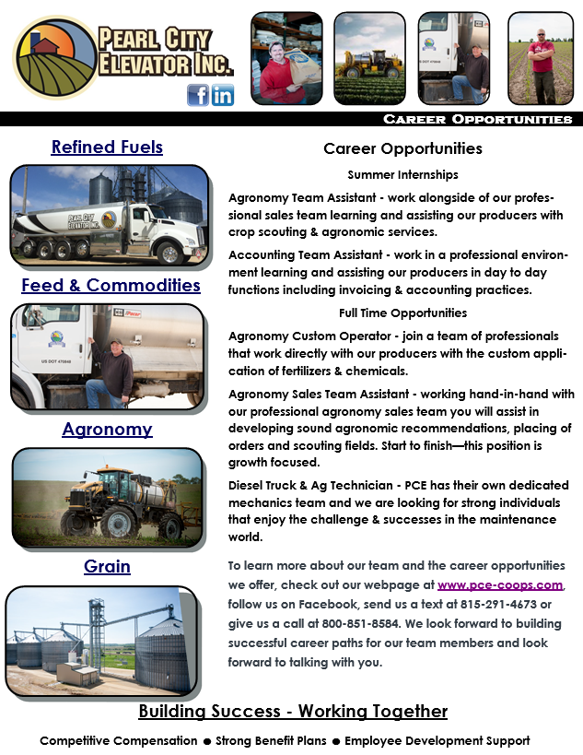

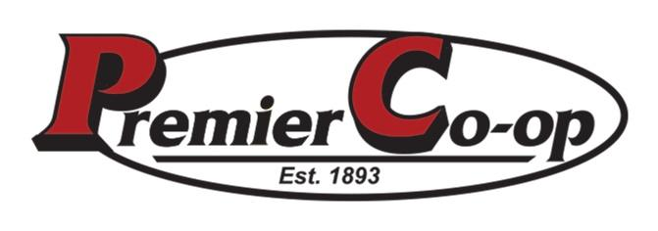

Premier Cooperative is an agriculture and consumer supply business, dedicated to providing its members/owners with the products and services they desire. As a cooperative, Premier Cooperative returns its profits each year to its members based on the amount of business (patronage) each member does with the company. Established in 1893 as Patrons’ Mercantile Cooperative, Black Earth, Premier is recognized as the oldest consumer and farm supply cooperative in the United States.

Premier operates many different businesses within the Cooperative and has locations in 19 communities throughout Wisconsin. The agronomy division’s 12 locations feature highly trained specialists in everything from plant nutrient deficiencies to custom application of plant food and crop protection products. In 2009 Premier opened a new state-of-the-art feed manufacturing facility in Mineral Point. In addition, Premier operates two additional mills and a dedicated organic feed mill in Westby. In 2016 Premier broke ground on a new feed manufacturing facility in Westby producing both organic and conventional feed. The feed division’s team of experienced nutritionists provides customers with the exact diet their livestock need to maximize production. The grain division’s four locations offer members a convenient solution to their drying, storage, and marketing needs. Premier’s retail divisions consist of four convenience stores, a growing number of automated fueling stations, a Do it Best and ACE Hardware, a full service lumber yard, and three automotive, truck and tire repair centers. The energy division services farm, businesses and homeowners alike with quality fuels, lubricants, propane, and sales/service work for their equipment. And finally, the administrative team provides the support functions of each department.

Shayla Danz

Human Resources

PO Box 230

Mount Horeb, WI 53572

608-308-4922

[Shayla.danz@premiercooperative.com](mailto:Shayla.danz@premiercooperative.com)

[www.premiercooperative.com](http://www.premiercooperative.com)

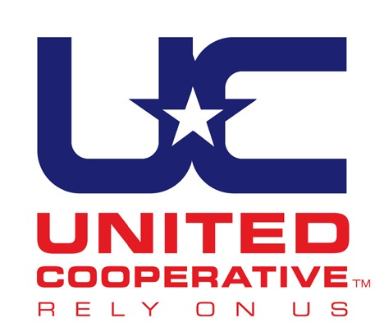United Cooperative is a full-service cooperative offering feed, grain, agronomy and energy products to more than 20,000 members from Wisconsin, Illinois, Iowa, Minnesota and the upper peninsula of Michigan. United Cooperative exists to provide its patron members (farmers and consumers) with the best possible value and return on investment, and aims to provide all its customers with professional, exceptional service. The United Cooperative headquarters is located in Beaver Dam, Wis. United Cooperative is Wisconsin's largest farmer-owned grain and farm supply cooperative and in 2017 was ranked #45 on USDA’s TOP 100 Agricultural Cooperatives list.

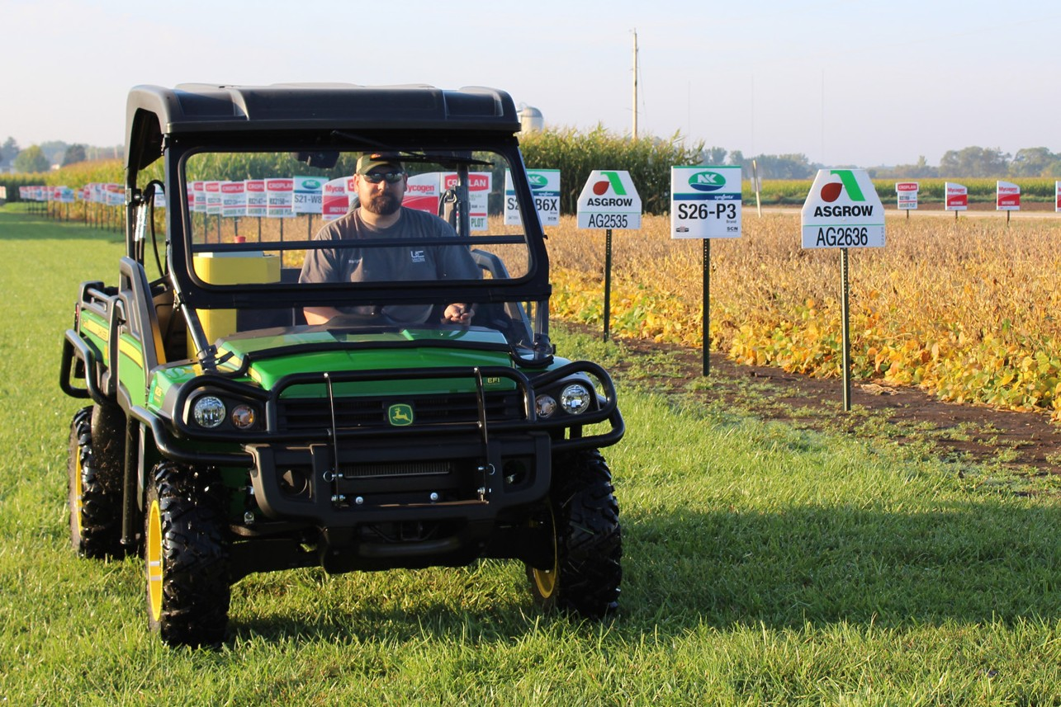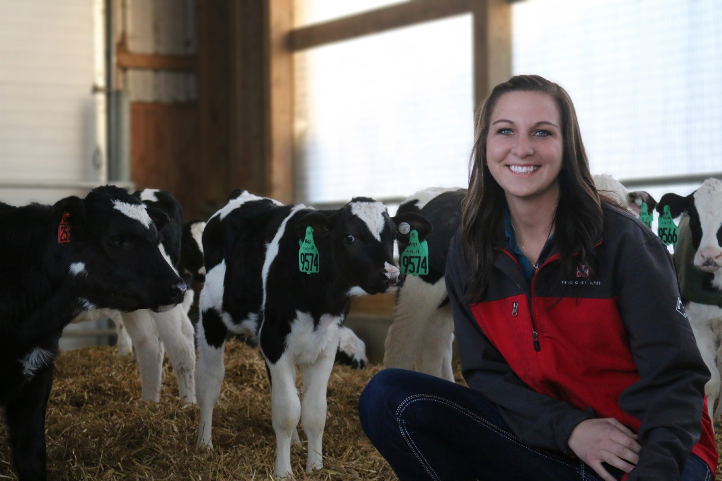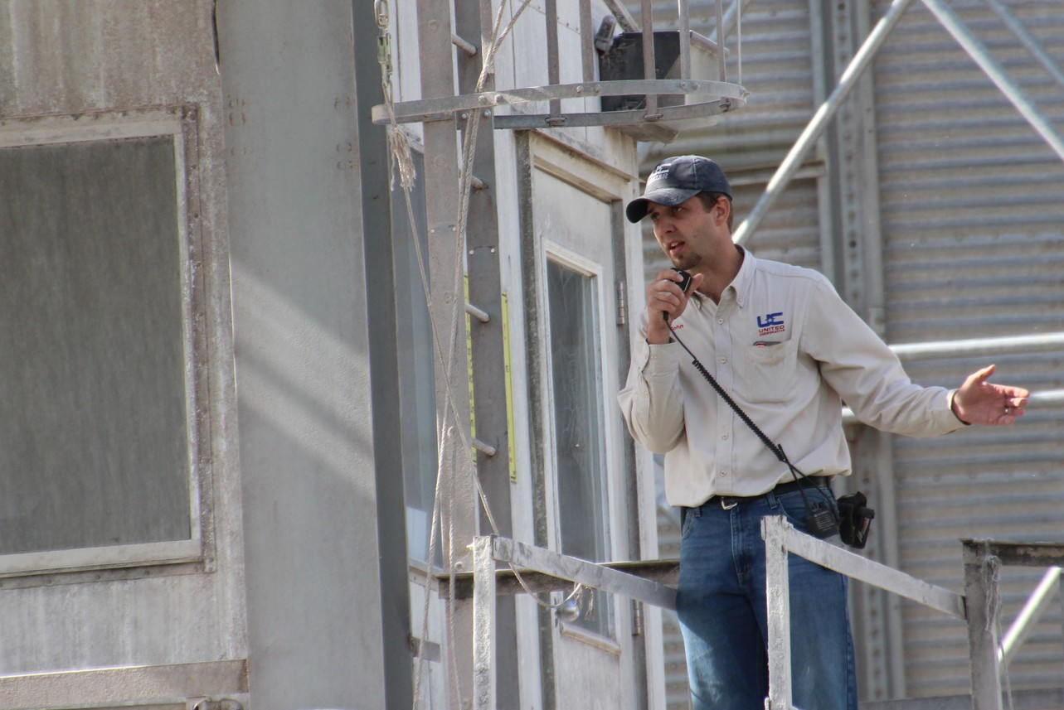

# Summer Agronomy Intern Technology Specialist

# Send your application, resume and cover letter to:

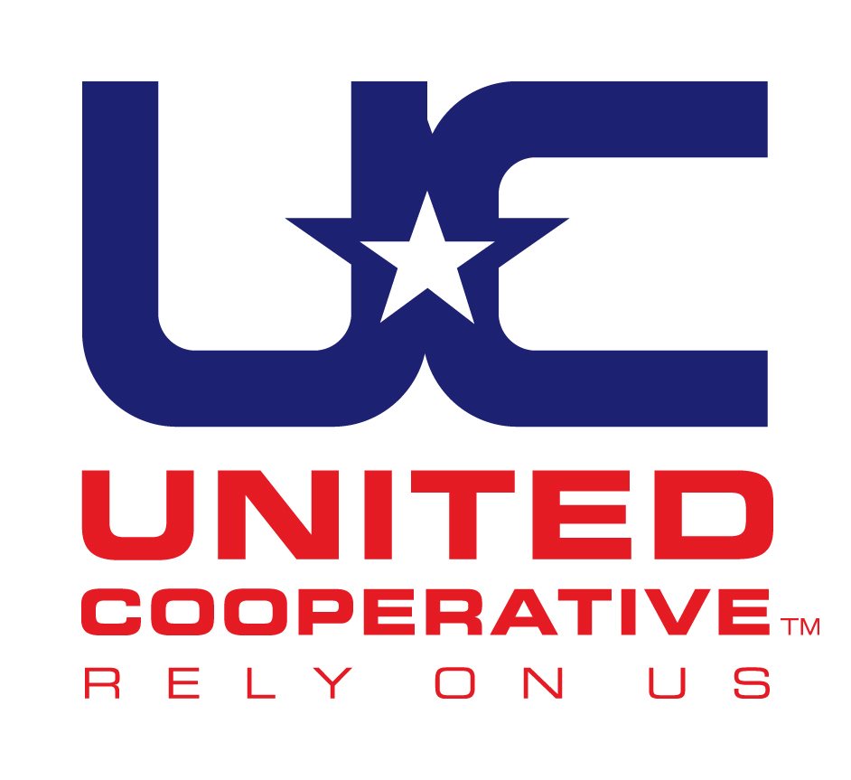

## [careers@unitedcooperative.com](mailto:careers@unitedcooperative.com)

United Cooperative Attn: Human Resources N7160 Raceway Road Beaver Dam, WI 53916

The application can be found at: [www.unitedcooperative.com/careers](http://www.unitedcooperative.com/careers)

*If there isn’t a current job posting that fits your skill set or area of expertise, we will consider you for future job openings.*

**UNITED COOPERATIVE IS AN EQUAL EMPLOYMENT OPPORTUNITY EMPLOYER**